**Part A. Identify.**

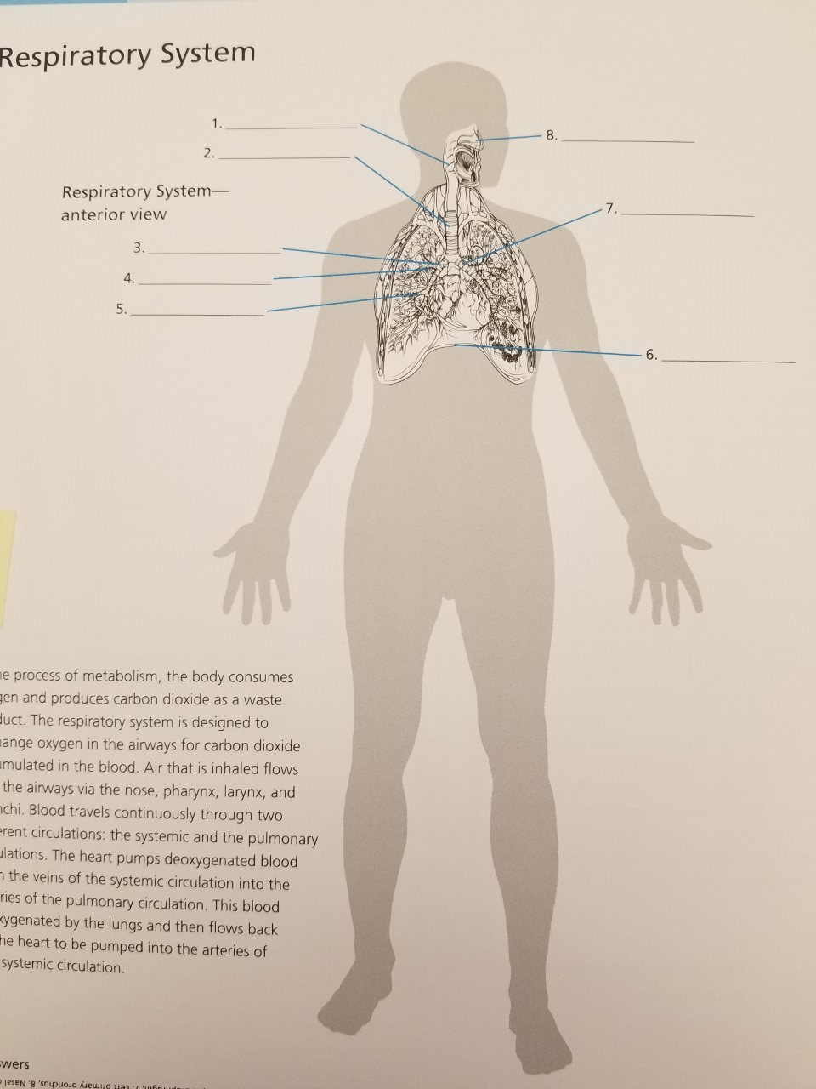

**Part B. Matching.** Match the part with its function. Letters may be used more than once.

1. Diaphragm
2. Trachea
3. Nasal cavity
4. Pharynx
5. Larynx
6. Lung
7. Pleura

1. passage way for air, food, and drink

2. has cartilage rings

3. respiration

4. helps lungs function optimally

5. helps expel vomit

6. moistens, warms, filters, and cleans inspired air

7. voice box for sound production

8. detects odors

9. during inhalation contracts enlarging the thoracic cavity

10. resonates sound

11. has epiglottis

**Part C. Identify.**

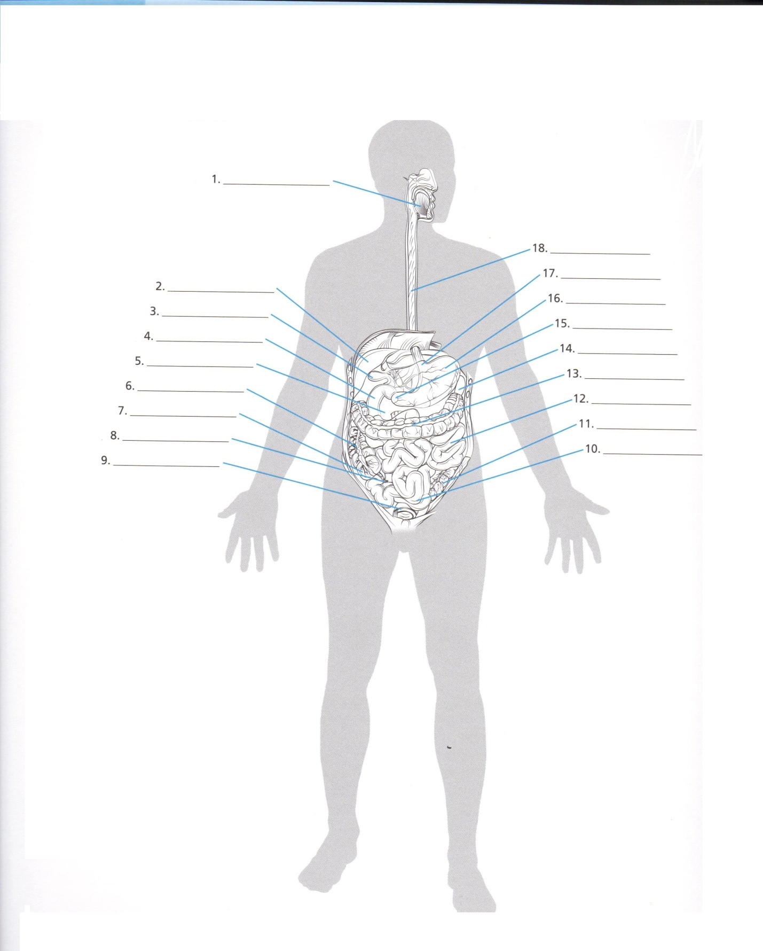

**Part D. Matching.**

Using key choices, match the following facts about pressure with the correct terms.

A. Atmospheric Pressure B. Intrapulmonary pressure C. Intrapleural pressure

1. Baring pneumothorax, this pressure is always lower than the atmospheric pressure – that is, is negative pressure

2. Pressure of air outside the body

3. As it decreases, air flows into the passageways of the lungs

4. As it increases over atmospheric pressure, air flows out of the lungs

5. If the pressure becomes equal to the atmospheric pressure, the lungs collapse

6. Rises well over atmospheric pressure during a forced cough

7. Also known as the intra-alveolar pressure

**Part E. Identify.** There are no numbers 1 or 2.

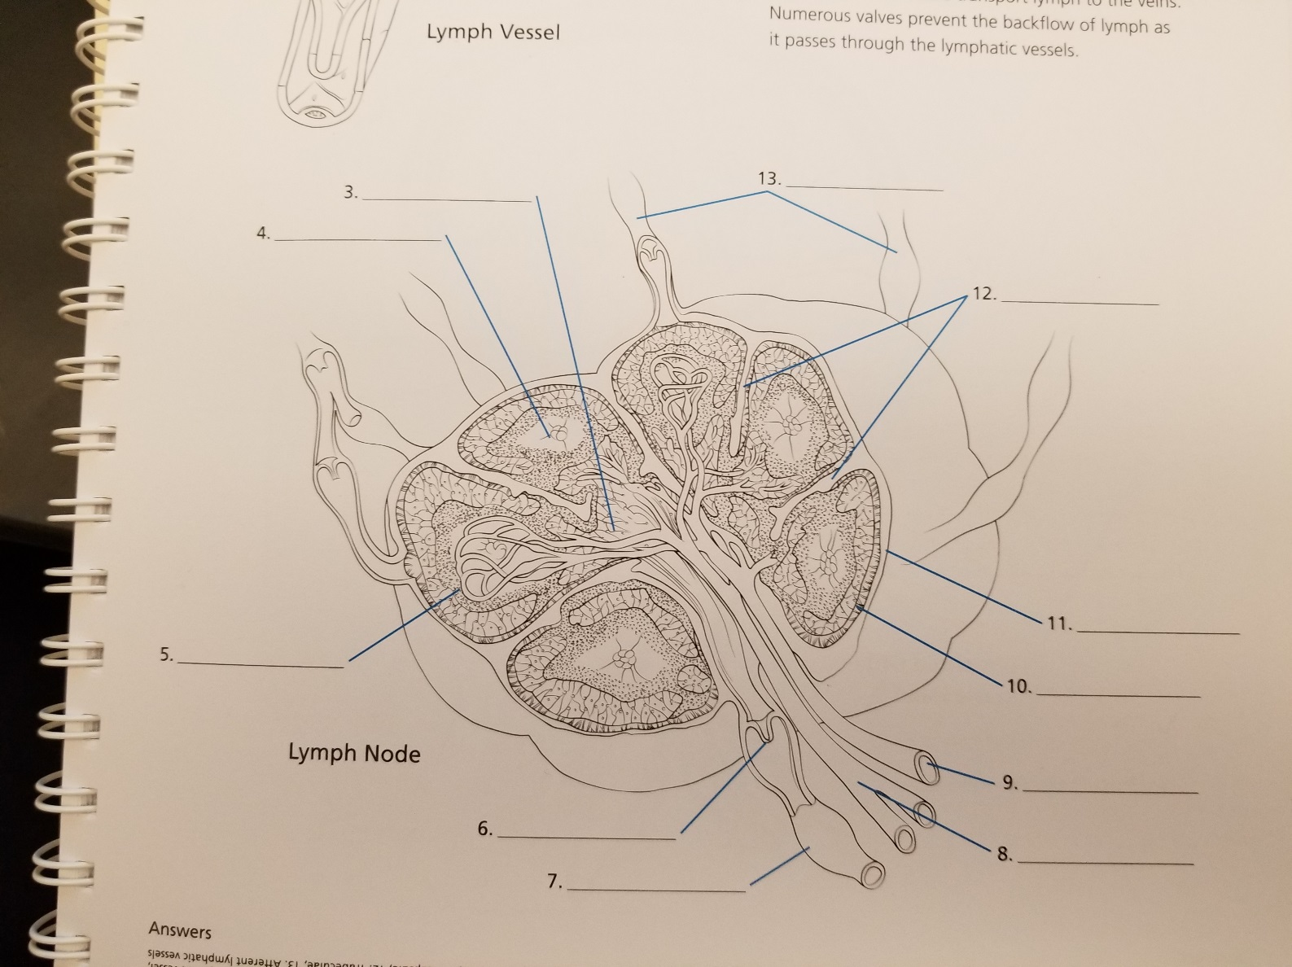

**Part F. Multiple Choice.** Choose the best letter to answer each question.

1. What is the most common way to diagnose cystic fibrosis?

a. sweat test c. blood test

b. pulmonary function test d. x-ray

2. A continuous positive airway pressure mask and machine are used to treat which disease?

a. COPD c. sleep apnea

b. pneumonia d. emphysema

3. During exercise this sends a signal to the lungs to increase breathing.

a. oxygen c. nitrogen

b. carbon dioxide d. salt

4. Churning occurs in the ____________________.

a. mouth c. stomach

b. small intestine d. large intestine.

5. Inflammation of the liver commonly caused by 3 viruses A, B, and C is called ___________.

a. hepatitis c. crohn’s

b. celiac d. appendicitis

6. The volume of air that can be exhaled after normal exhaltation is the ___________________

a. tidal volume c. residual volume

b. inspiratory reserve volume d. expiratory reserve volume

7. The volume of air in a normal breath is called ________________.

a. total lung capacity c. vital capacity

b. residual volume d. tidal volume

8. Gas exchange in the lungs happens by the process of ______________.

a. osmosis c. diffusion

b. exocytosis d. active transport

9. About how many miles of airways do your lungs contain?

a. 150 miles c. 100 miles

b. 1500 miles d. 500 miles

10. The primary chemical stimulus for breathing is the concentration of __________________.

a. carbon monoxide in the blood c. carbon dioxide in the blood

b. oxygen in the blood d. carbonic acid in the blood

11. Which muscle(s) is (are) contracted to exhale forcibly?

a. diaphragm alone c. external intercostals and diaphragm

b. internal intercostals and rectus abdominus d. rectus abdominis and diaphragm

12. Hyaline cartilage has what primary function?   
a. protect the thyroid c. connect the conchae  
b. increase the surface area d. support the trachea

13. Inhaled steroids, bronchodilators, and inhaled anticholinergics are all __________.

a. components in treatment of asthma

b. components in the treatment of sleep apnea

c. components in treatment of pulmonary fibrosis

d. not used to treat asthma

14. There are _______ lobes in the right lung, and _______ lobes in the left lung.

a. three, two c. two, two

b. two, three d. three, three

15. When parts of the lung remain uninflated on inspiration, this is known as _____________.

a. asthma c. atelectasis

b. pneumonia d. emphysema

16. The exchange of gases occurs in the ________________.

a. tracheac. alveoli

b. bronchioles d. bronchus

17. Where does most of the absorption of water and formation of feces take place?  
 a. stomach c. small intestine  
 b. large intestine d. liver

18. Most oxygen in the blood is transported ____________________.  
a. as gas dissolved in plasma c. as carboxyhemoglobin  
b. as oxyhemoglobin d. as bicarbonate

19. Oxygen from the air enters the blood stream at what location?  
a. cardiac notch c. alveoli  
b. pulmonary vein d. paranasal sinuses

20. The structure that closes off the larynx is the _______________________.

a. glottisc. epiglottis

b. Adam’s apple d. vocal cords

21. Our breathing is controlled by the part of the brain called the _______________.

a. cerebrum c. spinal cord

b. medulla oblongata d. hypothalamus

22. The exchange of gases between blood and cells is called _________________.

a. pulmonary ventilation c. external respiration

b. internal respiration d. cellular respiration

23. Bile aids the digestion of ___________________.

a. carbohydrates c. fats

b. proteins d. vitamins

24. Which type of nutrient is sodium?

a. vitamin c. mineral

b. protein d. fat

25. Most absorption within the gastrointestinal tract takes place in the ____________.

a. pancreas c. stomach

b. small intestine d. large intestine

26. Chemical digestion begins in the _________________.

a. mouth c. stomach

b. esophagus d. small intestine

27. Lacteals are ________________.

a. excellent sources of thiamin c. found within the stomach

b. associated with the large intestine d. required for absorption of fatty acids

28. It is common to talk about intensity of exercise using RPE, what does this stand for?

a. resting physical equivalents c. real perceptive exercise

b. rate of physical exercise d. rate of perceived exertion

29. Choose the correct choice depicting the path of food after mastication leading up to digestion.

I. Stomach IV. Esophagus

II. Pharynx V. Small Intestine

III. Large Intestine

a. I, II, III, IV, V c. II, IV, I, V, III

b. V, IV, III, II, I d. II, IV, I, III, V

30. What bacteria is one of the main causes of ulcers in the stomach?

a. *Helicobacter pylori* c. *Plasmodium falciparum*

b. *Pseudomonas aeruginosa* *d. Streptococcus pyrogenes*

31. Some causes of lactose intolerance can be attributed to __________________.

I. Bowel Surgery

II. Infection in small intestine

III. Celiac Sprue (Intestinal disease)

a. I and II c. I, II, and III

b. II and III d. None of the above

32. Appendicitis is the inflammation of which of the following descriptions?

a. Structure consisting of skeletal muscle and attached to the stomach

b. Structure consisting of skeletal muscle and attached to the large intestine

c. Structure consisting of smooth muscle and attached to the small intestine

d. Structure consisting of smooth muscle and attached to the large intestine

33. Celiac disease destroys the lining of which organ, making it harder for certain parts of the food to be absorbed?

a. Stomach c. Pancreas

b. Large Intestine d. Small Intestine

34. Stomach cancer afflicts which organ?

a. Small intestine c. Stomach

b. Large Intestine d. Larnyx

35. Identify the correct choice indicating the three types of diarrhea.

a. gastric, pancreatic, insulinic c. osmotic, secretory, exudative

b. pulmonary, gastric, peritoneal d. phlebitic, somatic, nephric

36. Which over-the-counter medication is NOT used for the treatment for diarrhea?

a. Pepto-Bismol c. Kaopectate

b. Imodium A-D d. Albuterol

37. Constant use of non-steroidal anti-inflammatory drugs (NSAIDs) increases the risks of which of the following?

I. Duodenal Ulcers

II. Peptic Ulcers

III. Gastric Ulcers

a. I only c. I and III

b. II only d. I, II, and III

38. These cells located in gastric glands produce and secrete pepsinogen.

a. parietal c. mucus secreting

b. chief d. hormone secreting

39. The lamina propria is connective tissue located in which layer of the alimentary canal?

a. mucosa c. submucosa

b. *muscularis externa* d. adventitia

40. Which of the following is NOT a location where mechanical digestion occurs?

a. large intestine c. small intestine

b. mouth d. stomach

41. At altitude the rate of diffusion of oxygen across the pulmonary and tissue capillaries is decreased resulting in a drastic decrease in hemoglobin saturation during exercise. Which one of the following would account for this decrease?

a. Decrease in the partial pressure of oxygen in the ambient air

b. Decrease in portion of oxygen in the ambient air

c. Decrease in the oxygen equilibrium of the capillaries to the alveoli

d. All of the above

42. Identify the term for the following pattern of breathing: labored, gasping breathing, and shortness of breath.

a. Apnea c. Hyperpnea

b. Dyspnea d. Tachypnea

43. Which of the following are ways exercise affects the digestive system?

1. Strengthen digestive tract
2. Relieve constipation
3. Temporary heartburn
4. All of the above

44. Use the oxygen-dissociation curve pictured below to answer the question.

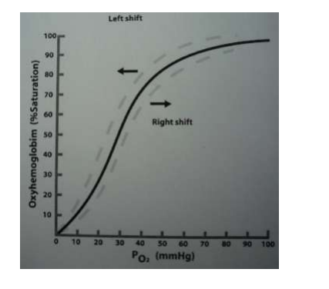

What factors would increase the amount of oxygen unloading into tissues?

a. High temperature

b. Low 2, 3-DPG

c. High pH

d. Low pCO2

45. Which cells destroy parasitic worms?

1. Mast cells
2. Helper T cells
3. Eosinophils
4. Monocytes

46. Which line of defense is most involved in the inflammation process?

1. First line of defense
2. Second line of defense
3. Third line of defense
4. Fourth line of defense

47. What is the name of the response process that defends against intracellular pathogens and cancer by binding to and lysing these cells?

1. Humoral immune respone
2. Lag time immune response
3. Process 1 response
4. Cell-mediated immune response

48. Which of the following is NOT in the bodies second line of defense?

1. Phagocytic blood cells
2. Antimicrobial proteins
3. Mucosae
4. White blood cells

49. All of the following organs actively fight pathogens except:

1. Thymus
2. Tonsils
3. Spleen
4. Axillary lymph nodes

50. Which of the following is NOT associated with inflammation?

1. Redness
2. Swelling
3. Decreased capillary permeability
4. Pain

51. Lymph is moved through lymphatic vessels because of:

1. Ventricular contraction
2. Flapping of lymphatic valves
3. Pumping by the smooth muscle of the lymphatic capillaries
4. Skeletal muscle contraction

52. Immunoglobulins that attach to mast cells and basophils and are involved in allergic reactions are:

1. IgA
2. IgE
3. IgD
4. IgG

53. Lymphoid tissue:

1. Is often found beneath mucous membranes
2. Is a tissue that lacks cells
3. Is NOT found within the digestive tract
4. Usually functions to promote bacterial and viral replication

54. Lymph nodes:

1. Are only found in the cervical, inguinal, and axillary regions
2. Are NOT surrounded by a connective tissues capsule
3. Have a cortex that will contain B lymphocytes
4. Typically have more efferent lymph vessels than afferent lymph vessels

55. The normal constituents of plasma, lymph, and interstitial fluid are _____________.

1. Water, proteins, and red blood cells
2. Water only
3. Water and proteins
4. Water and red blood cells

56. The majority of the body’s lymph drains from the:

1. Thoracic duct into the right subclavian vein
2. Right lymphatic duct into the right subclavian vein
3. Left lymphatic duct into the left subclavian artery
4. Cisterna chyli into the abdominal vena cava

57. Which cells are attacked by the HIV virus?

a. Eosinophils

b. Basophils

c. Mast Cells

d. Helper T Cells